

**Comic Book Store**

Created by: Ilyas Ahamedi, Grant Edwards, Cameron Krueger



**Table of Contents**

1. Problem Definition
2. Table Structure
3. Table Design
4. Relationship Diagram
5. Table Datasheet Views

9. Queries

14. Forms Output

16. Report Outputs

**Problem Definition**

Our project is to create a small working database for a business of our choice. The business type that we have chosen and checked over with the professor is a Comic Book Store.

We will need queries that sort information about the employees of the store as well as it’s customers and content (comics). There will also be a query that displays the favourite comics of our registered customers, and which ones are within an affordable spending range for mid-to-low income households in the coming holiday season.

We plan to create forms that give us the ability to edit and view information pertaining to our customers, employees and merchandise, as well as one for viewing comic info as well as another for navigating the form.

There will be reports that display accumulated information about employees, as well as information regarding to our comics, their stock and basic info.

The types of tables that we’ll need are:

* Table: *tblPublisher*

|  |  |  |  |
| --- | --- | --- | --- |
| Field Name | Type | Size | Sample Values |
| **PublisherID** | AutoNumber | Default | 1 |
| PublisherName | Short Text | 40 | Marvel Comics |

* Table: *tblComic*

|  |  |  |  |
| --- | --- | --- | --- |
| Field Name | Type | Size | Sample Values |
| **ComicID** | AutoNumber | Default | 1 |
| PublisherID | Short Text | 3 | 1 |
| SeriesID | Short Text | 40 | BATMAN: |
| ComicName | Short Text | 60 | HARLEY QUINN |
| Price | Short Text | 8 | 21.99 |
| ComicImage | OLE Object |  |  |
| AmountInStock | Number | Long Integer | 113 |

* Table: *tblCustomer*

|  |  |  |  |
| --- | --- | --- | --- |
| Field Name | Type | Size | Sample Values |
| **CustomerID** | AutoNumber | 5 | 1 |
| CustomerLastName | Short Text | 40 | Edwards |
| CustomerFirstName | Short Text | 40 | Ilyas |
| CustomerEmail | Short Text | 80 | GrantCameronIlyas@dcmail.ca |
| ComicID | OLE Object |  |  |
| CustomerProfilePic | OLE Object |  |  |

* Table: *tblMerchandise*

|  |  |  |  |
| --- | --- | --- | --- |
| Field Name | Type | Size | Sample Values |
| **MerchandiseID** | AutoNumber | Default | 1 |
| **PublisherID** | Number | Integer | 12 |
| MerchandiseDescrpition | Short Text | 60 | Batman Mask |
| Price | Currency | 8 | 9.99 |
| ProductImage | OLE Object |  |  |
| SeriesID | Number | Integer | 12 |

* Table: *tblSeries*

|  |  |  |  |
| --- | --- | --- | --- |
| Field Name | Type | Size | Sample Values |
| **SeriesID** | AutoNumber | Long Integer | 1 |
| SeriesName | Short Text | 30 | Star Wars |
| SeriesPicture | OLE Object |  | Package |

* Table: *tblPosition*

|  |  |  |  |
| --- | --- | --- | --- |
| Field Name | Type | Size | Sample Values |
| **PositionID** | AutoNumber | Default | 1 |
| PositionName | Short Text | 25 | Manager |

* Table: *tblEmployee*

|  |  |  |  |
| --- | --- | --- | --- |
| Field Name | Type | Size | Sample Values |
| **EmployeeID** | AutoNumber | Default | 1 |
| EmployeeFirstName | Short Text | 30 | Cam |
| EmployeeLastName | Short Text | 30 | Kruger |
| Gender | Short Text | 2 | M |
| PositionID | Number | 2 | Manager |
| PhoneNumber | Short Text | 10 | 9054394753 |
| Email | Short Text | 60 | Grant.Edwards@dcmail.ca |
| EmployeeProfilePic | OLE Object |  |  |

**Table Design**

This shows the design for the Comic table

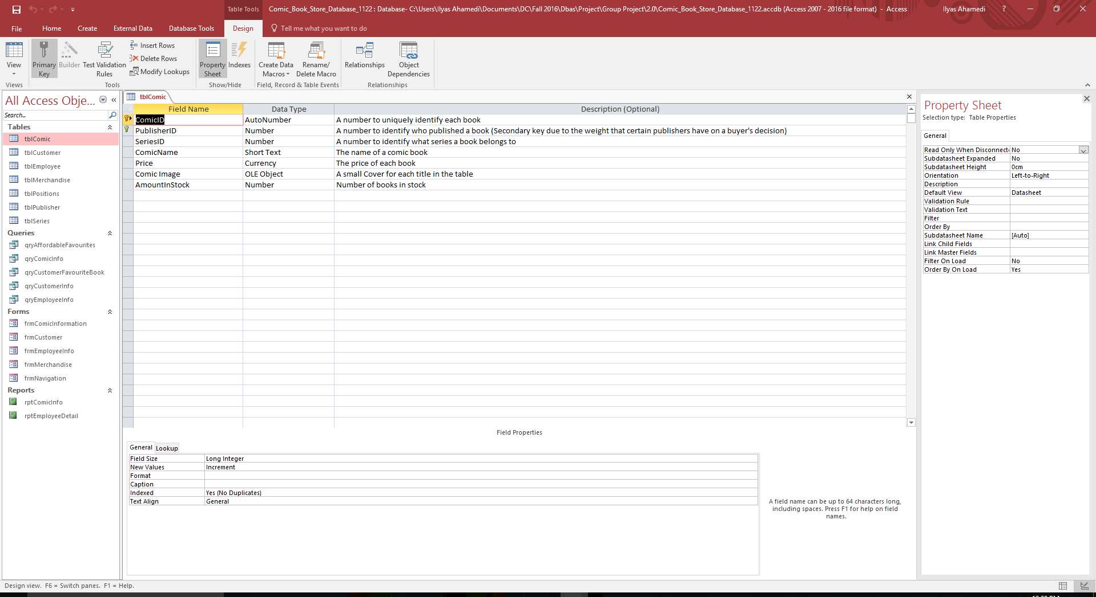

This shows the design for the Series table

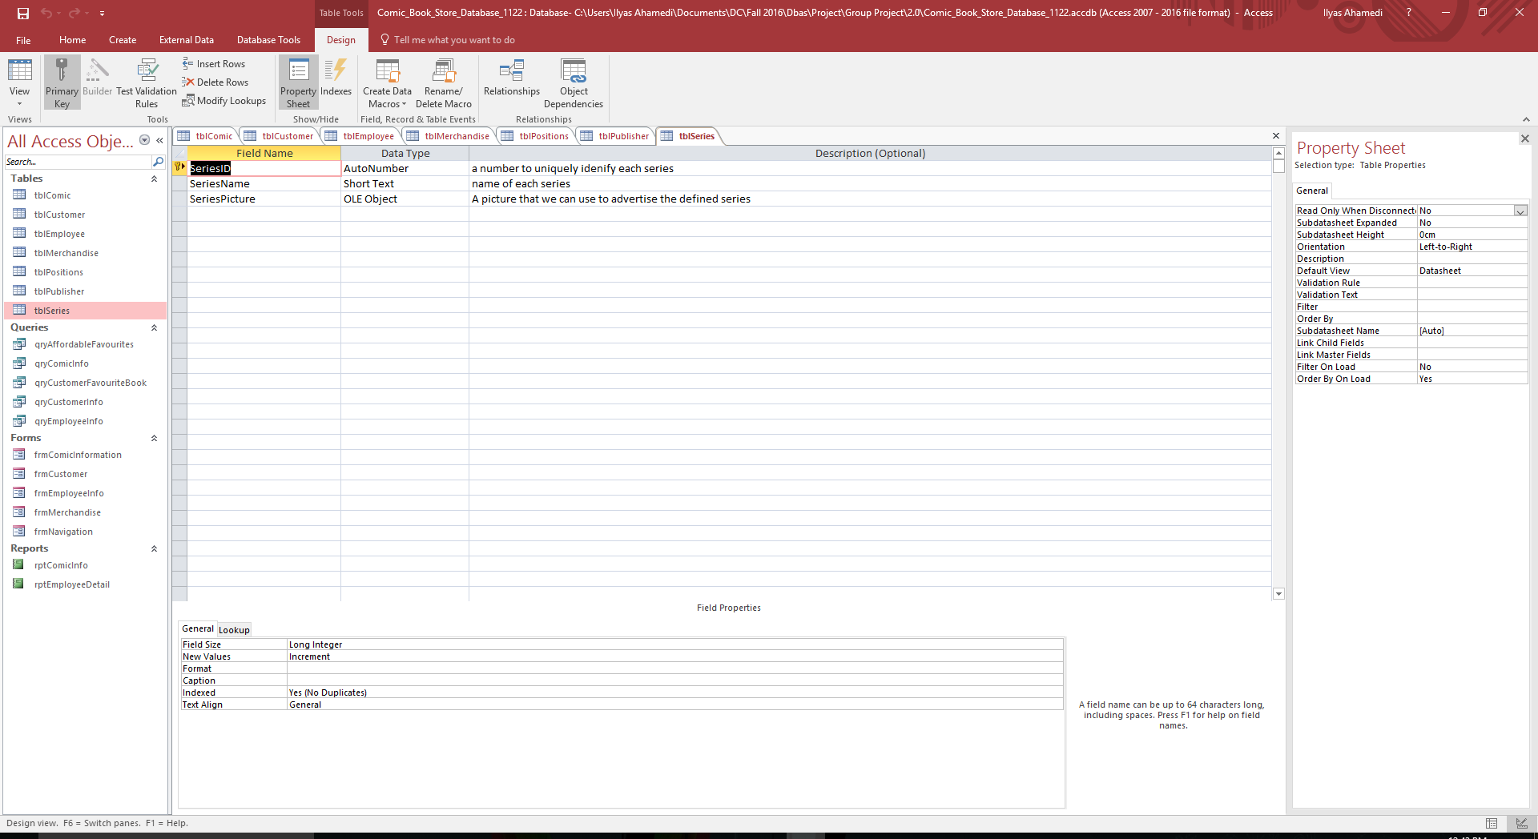

This shows the design for the Merchandise table

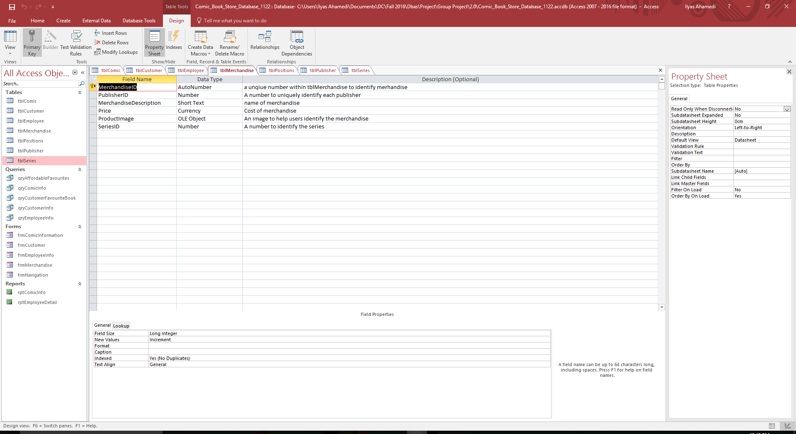

This shows the design for the Customer table

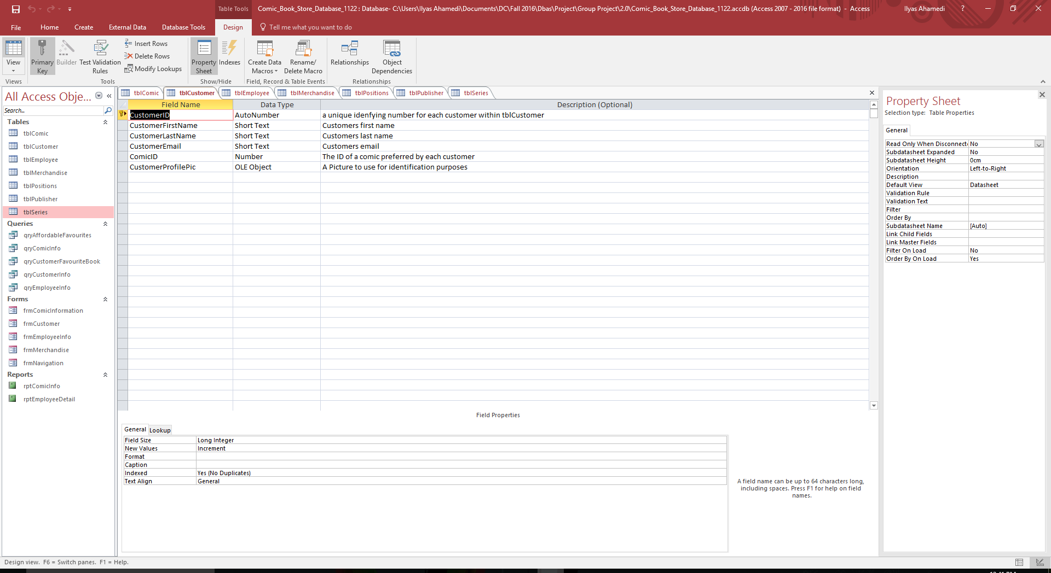

This shows the design for the Employee table

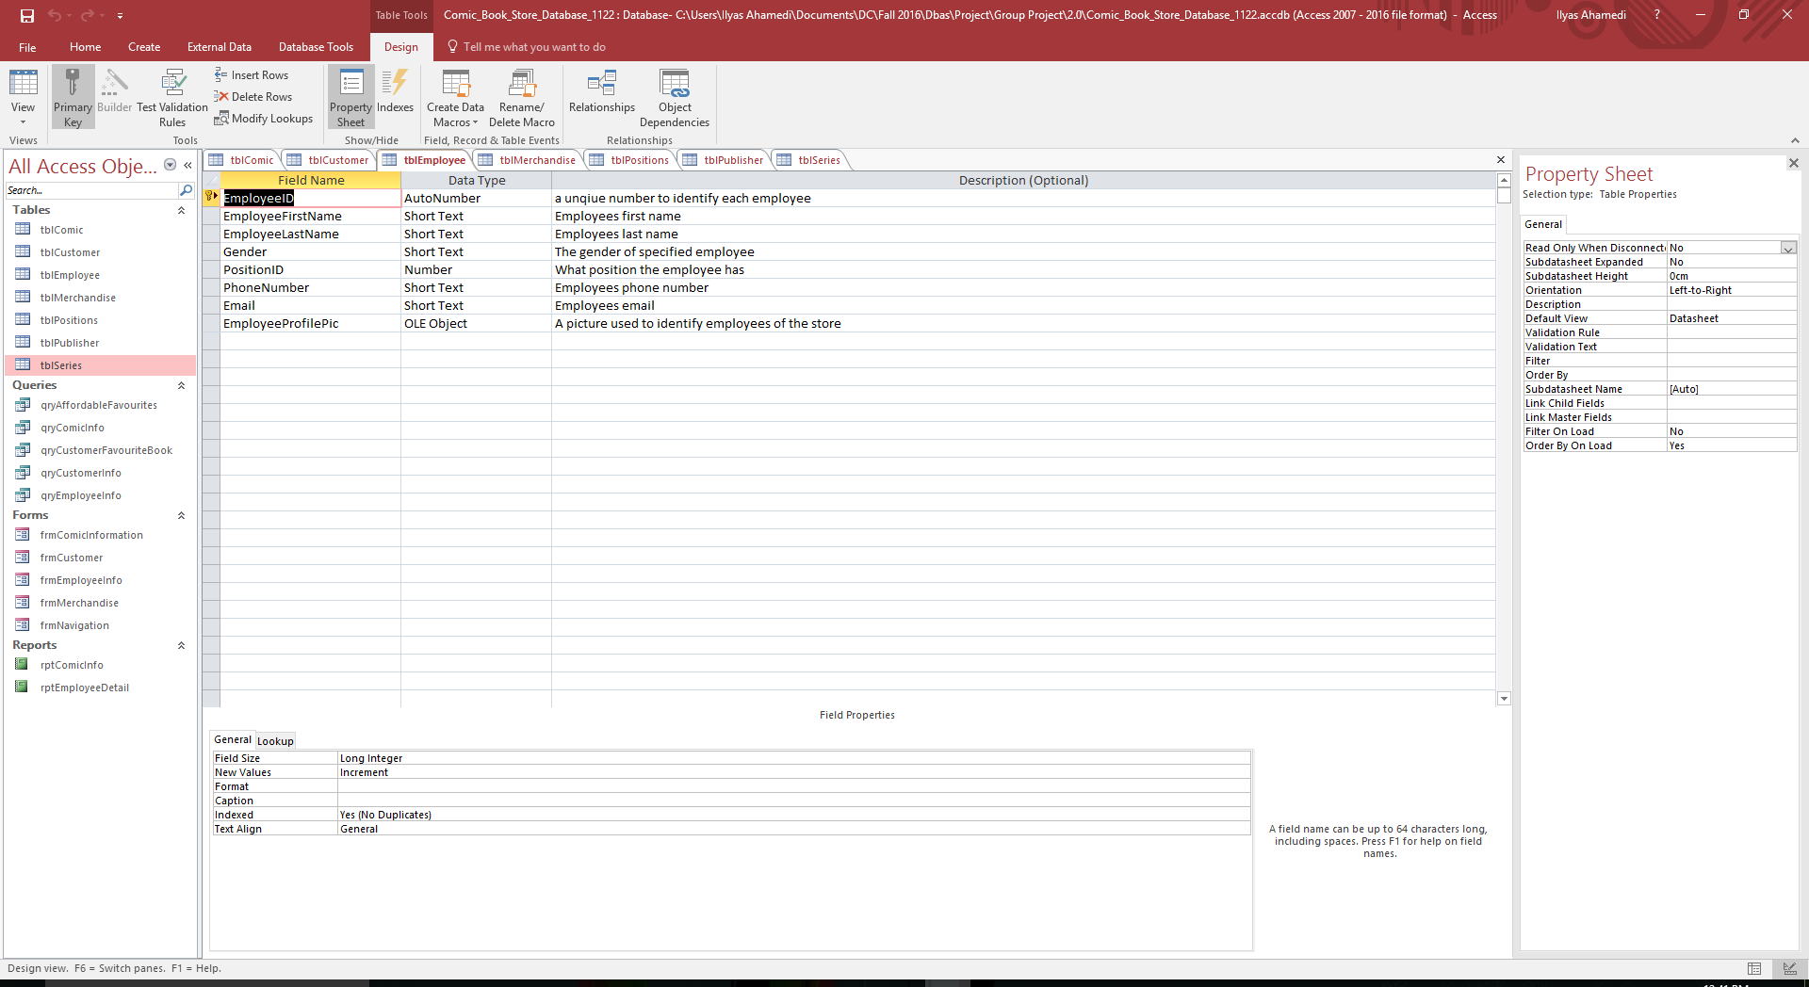

This shows the design for the Position table

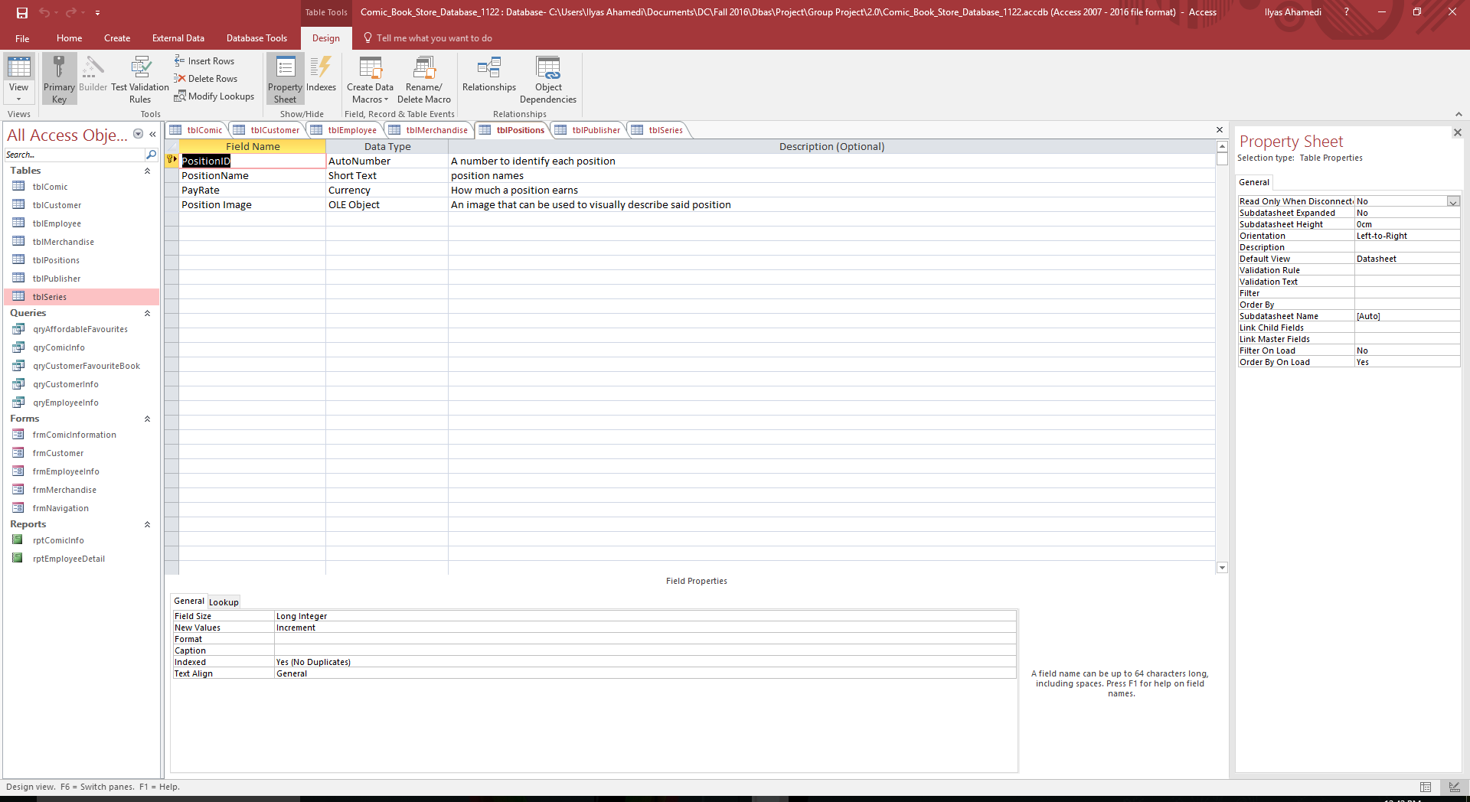

This shows the design for the Publisher table

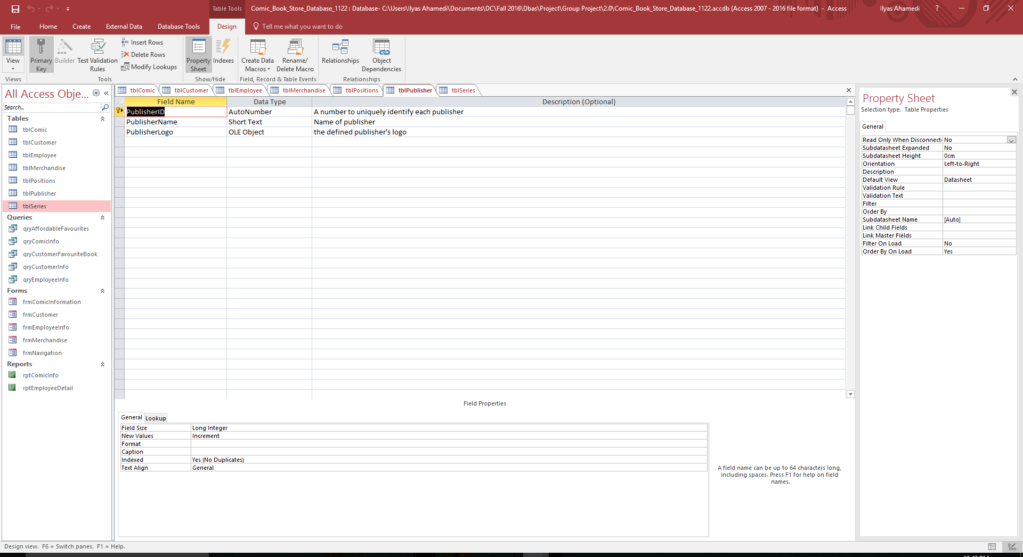

**Relationship Diagram**

This is the relationship diagram for our database and as you can see all our tables are related to each other.

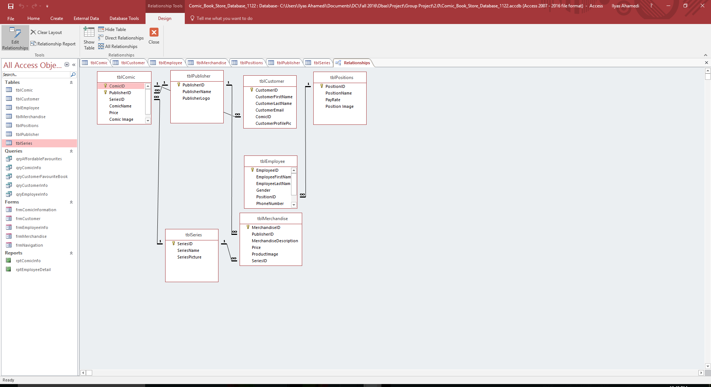

**Table Datasheet Views**

This shows the data that is in the Comic table

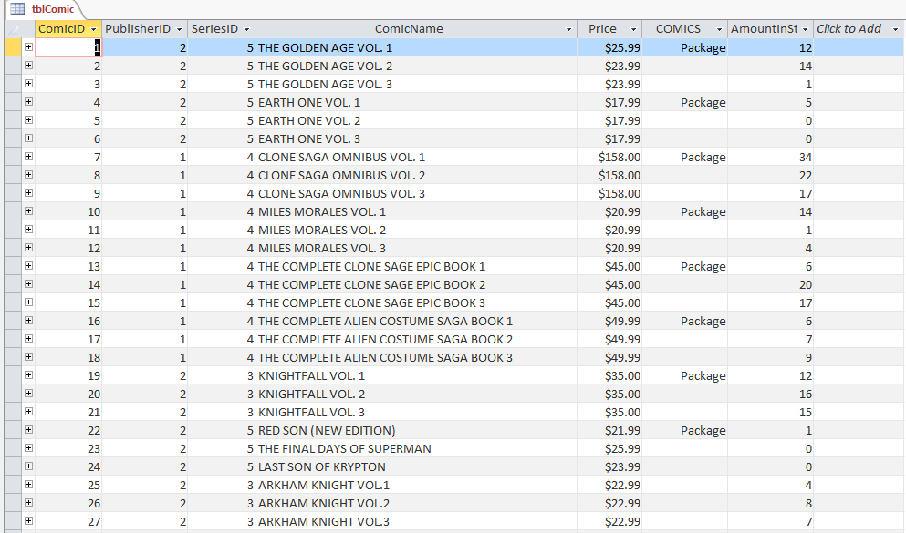

This shows the data that is in the Series table

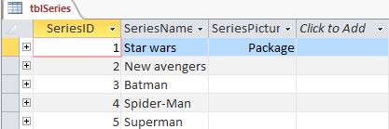

This shows the data that is in the Merchandise table

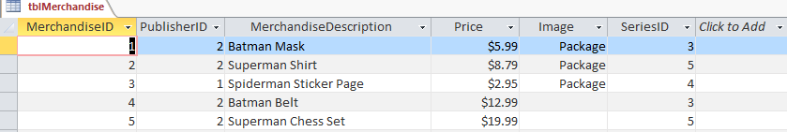

This shows the data that is in the Customer table

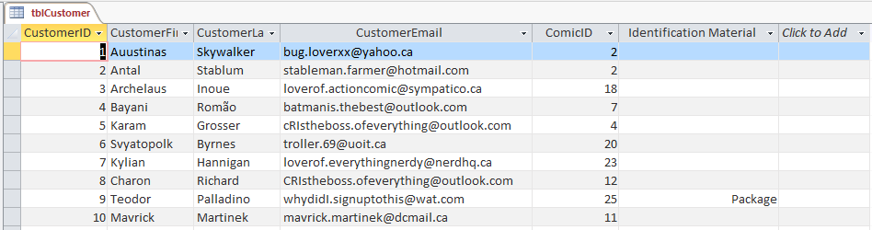

This shows the data that is in the Employee table

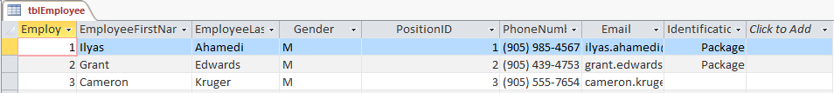

This shows the data that is in the Position table

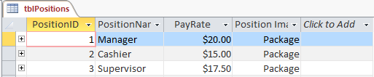

This shows the data that is in the Publisher table

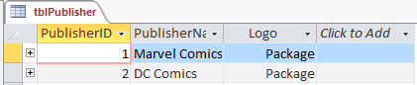

**Queries**

This shows the design and the data for the Affordable Favorites Query

Design

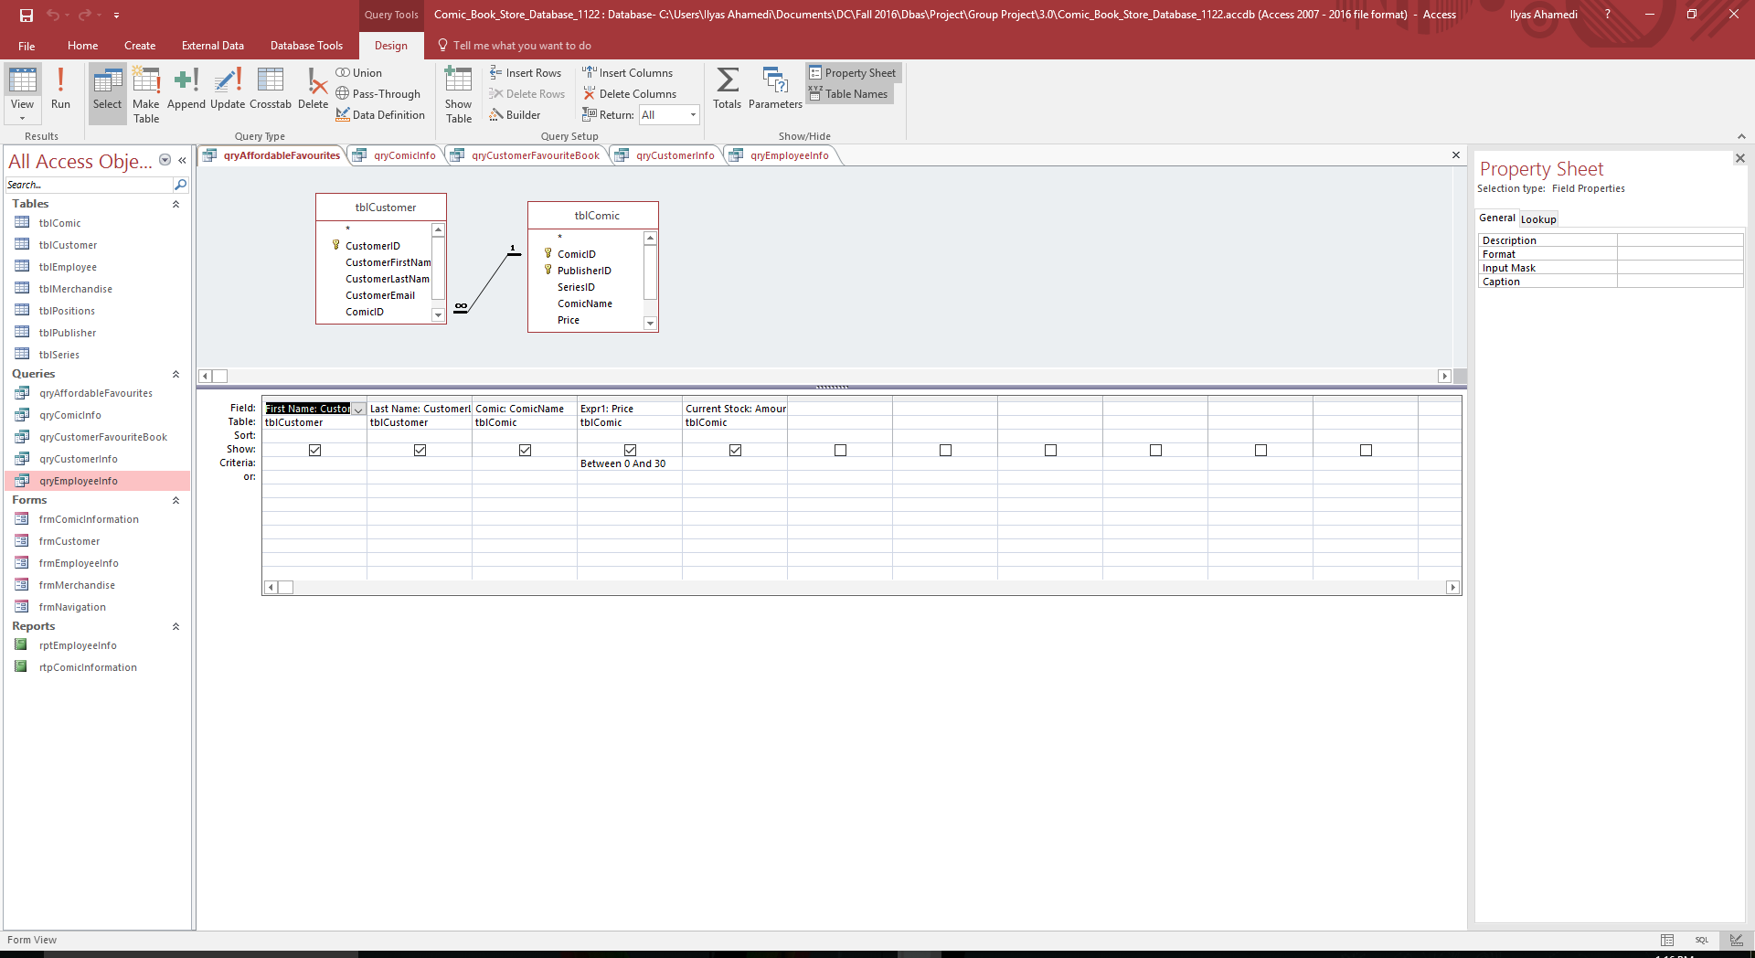

Data

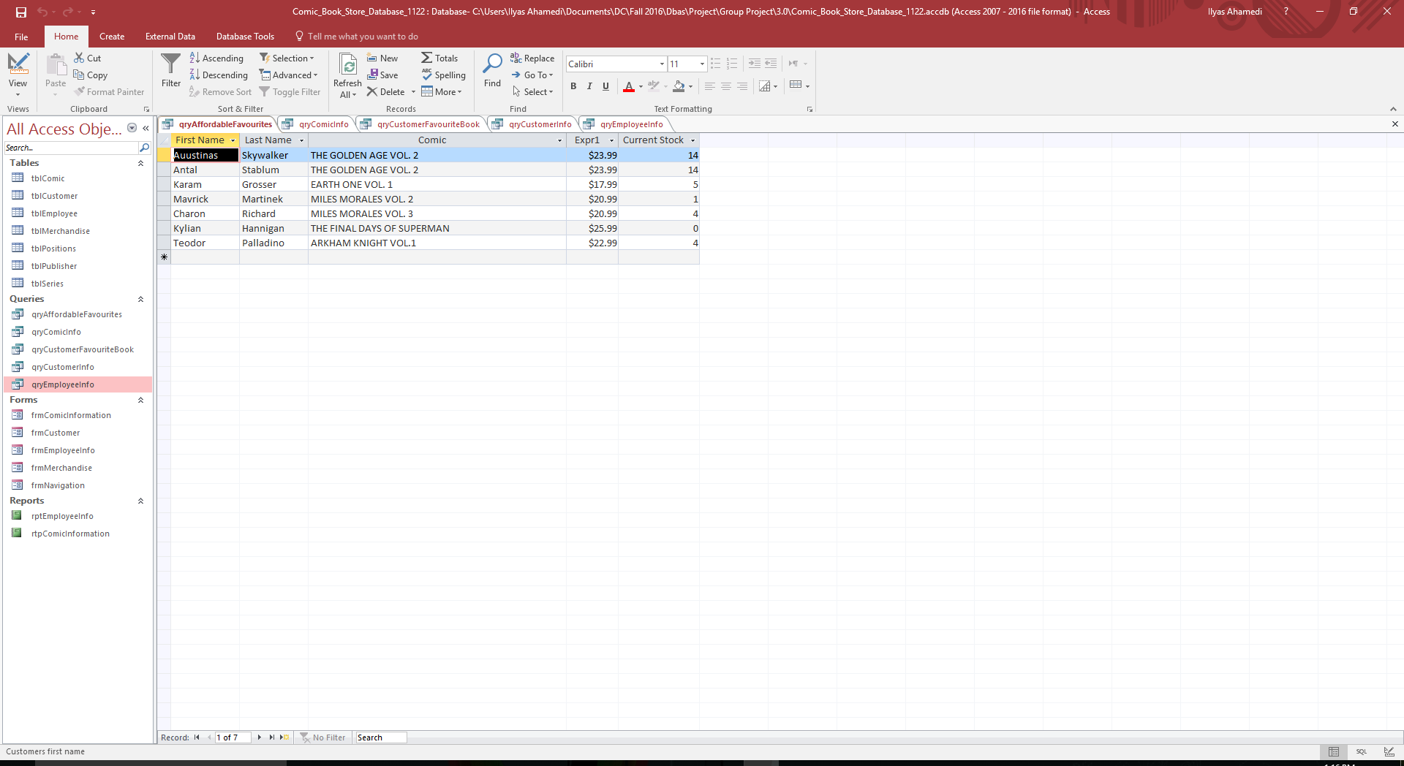

This shows the design and the data for the Comic Info Query

Design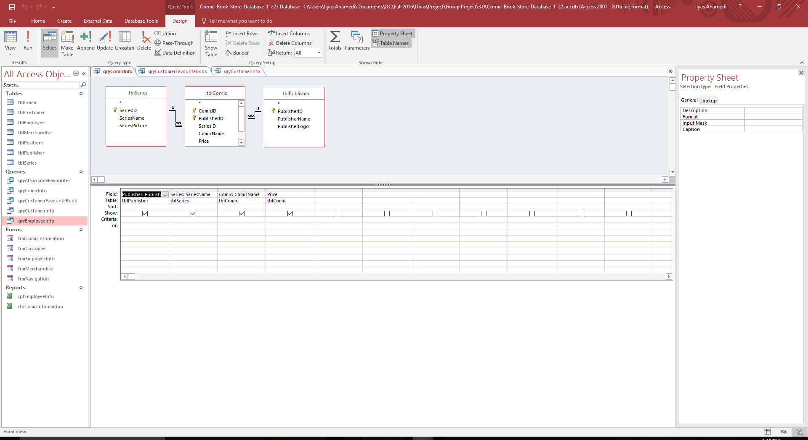

Data

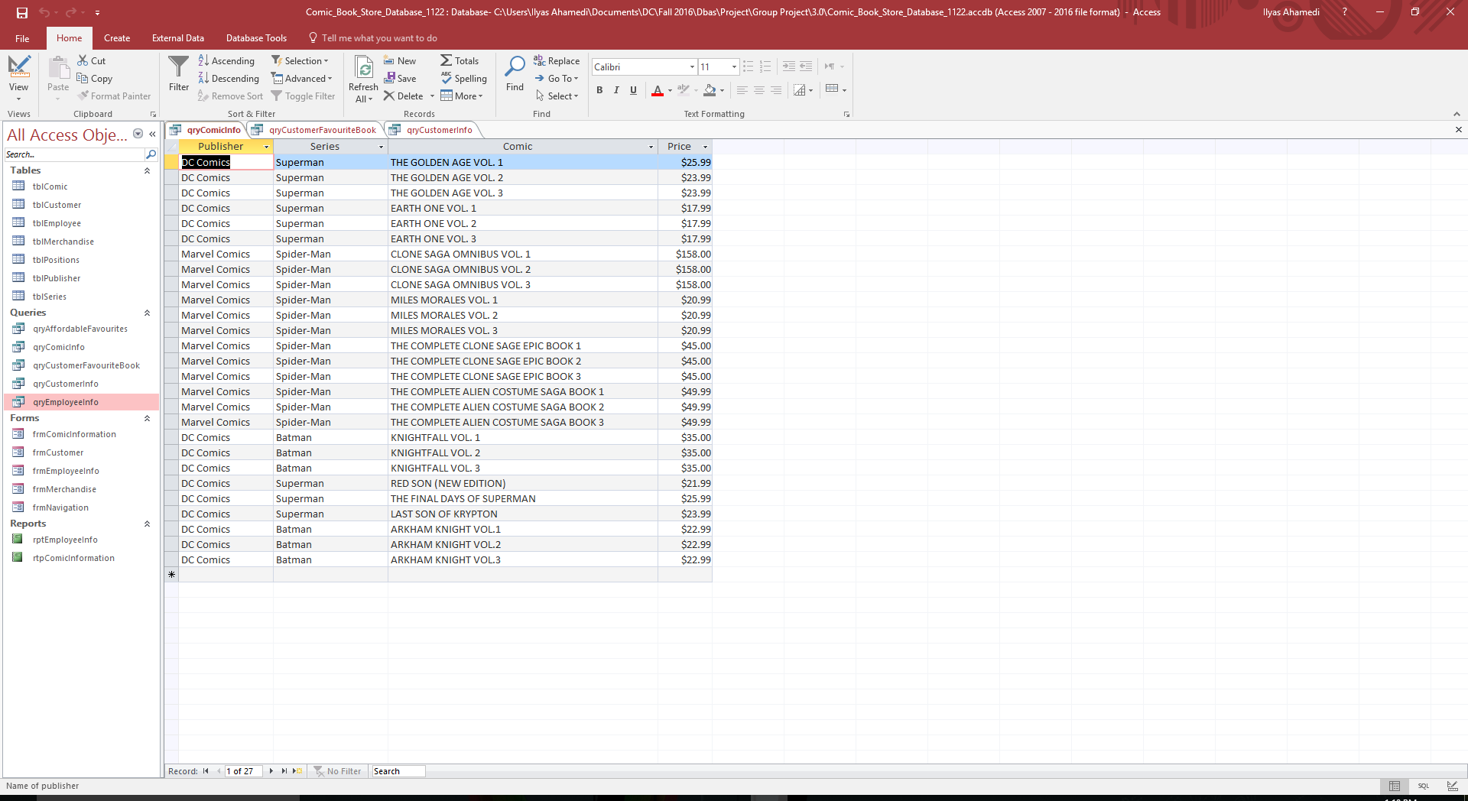

This shows the design and the data for the Customer Favorite Book Query

Design

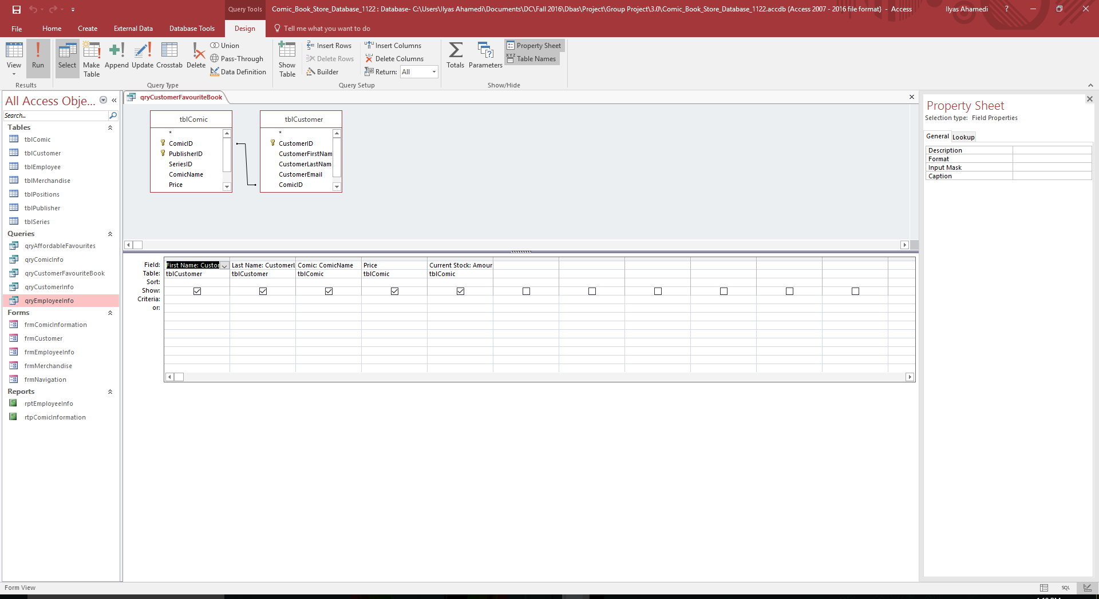

Data

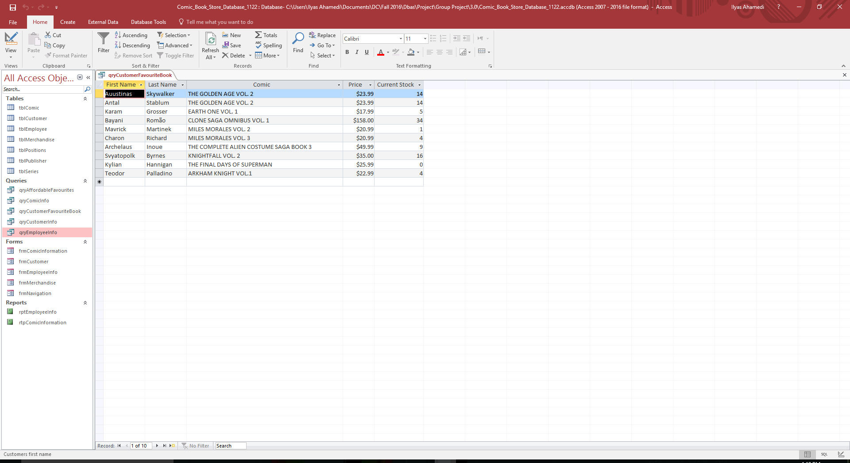

This shows the design and the data for the Customer Info Query

Design

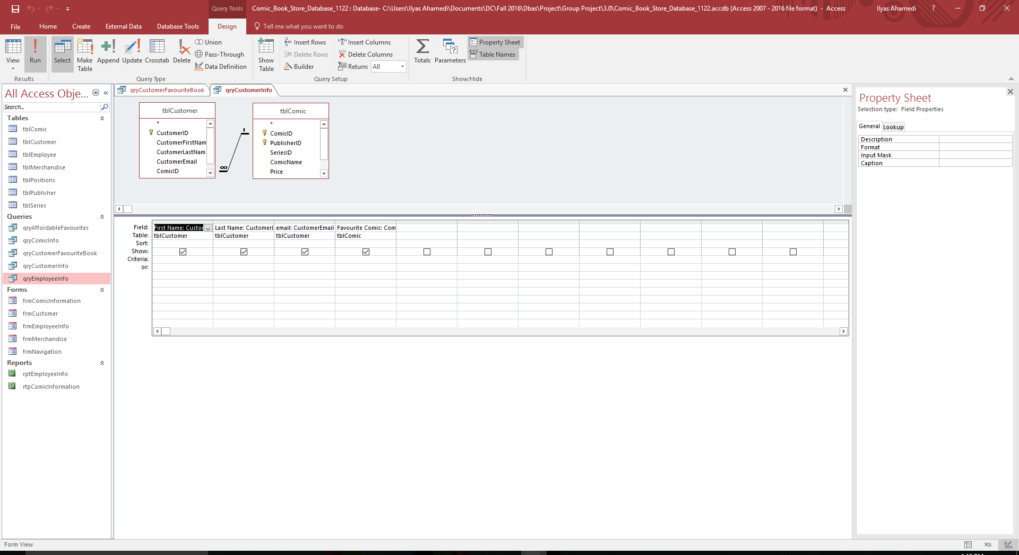

Data

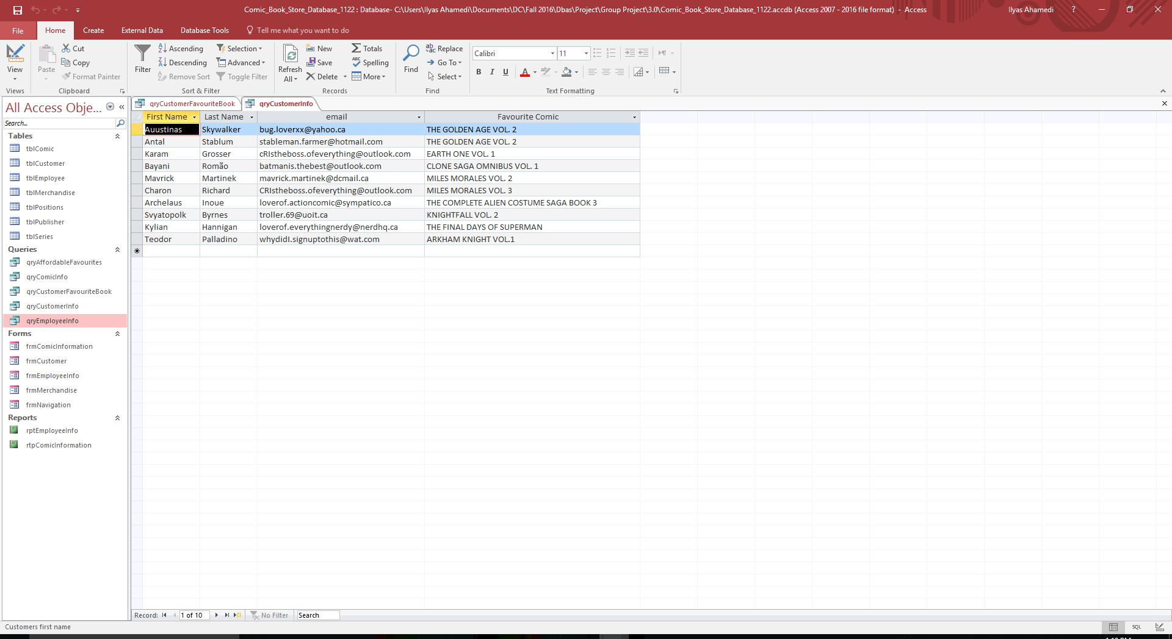

This shows the design and the data for the Employee Info Query

Design

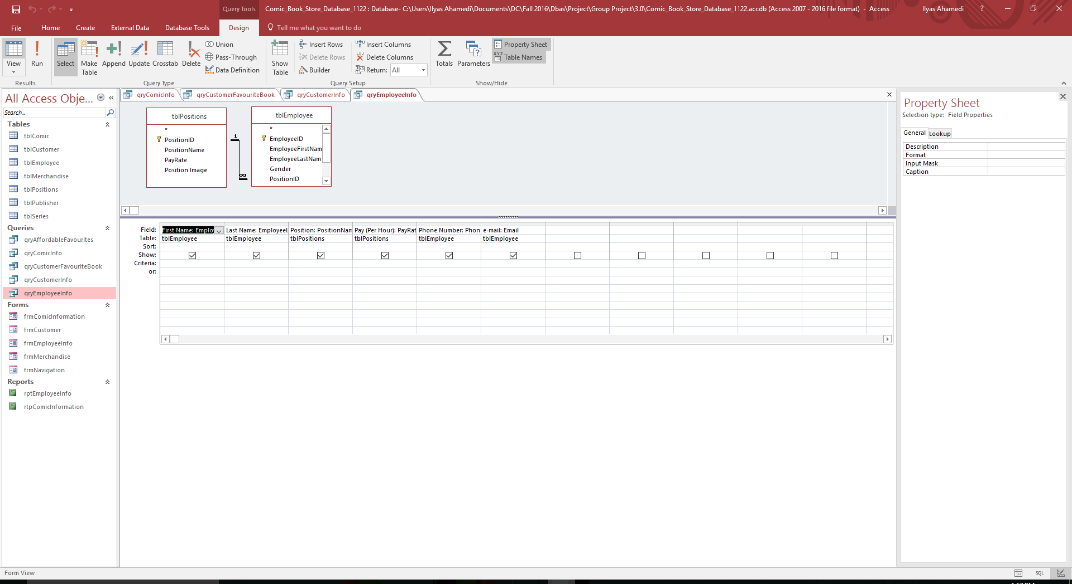

Data

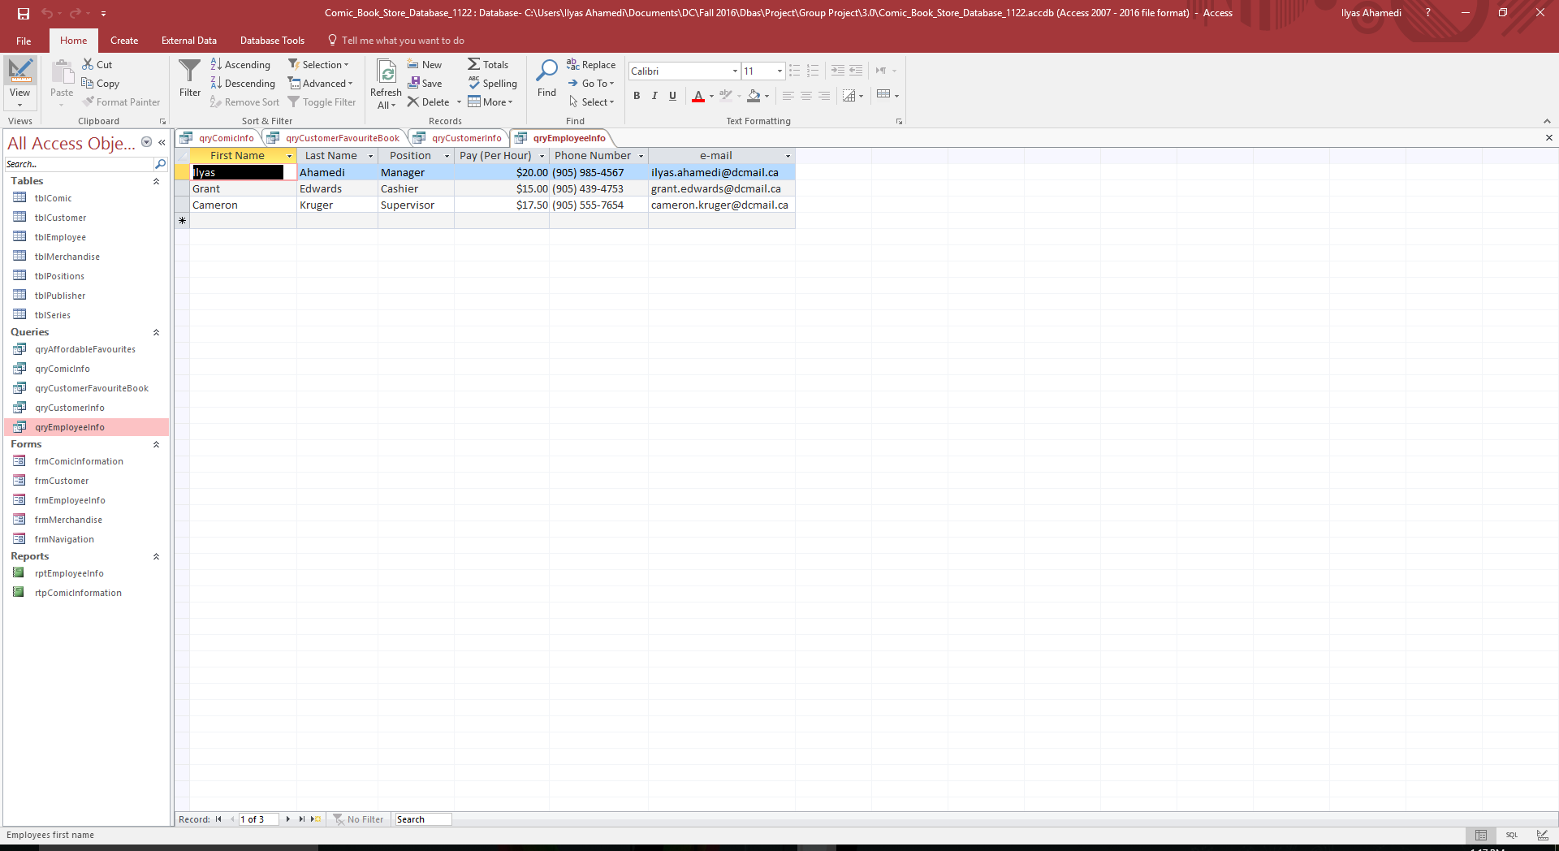

**Forms Output**

This is the Comic Information form and it shows the user, information about the comic (Publisher, Series, Name, ect.)

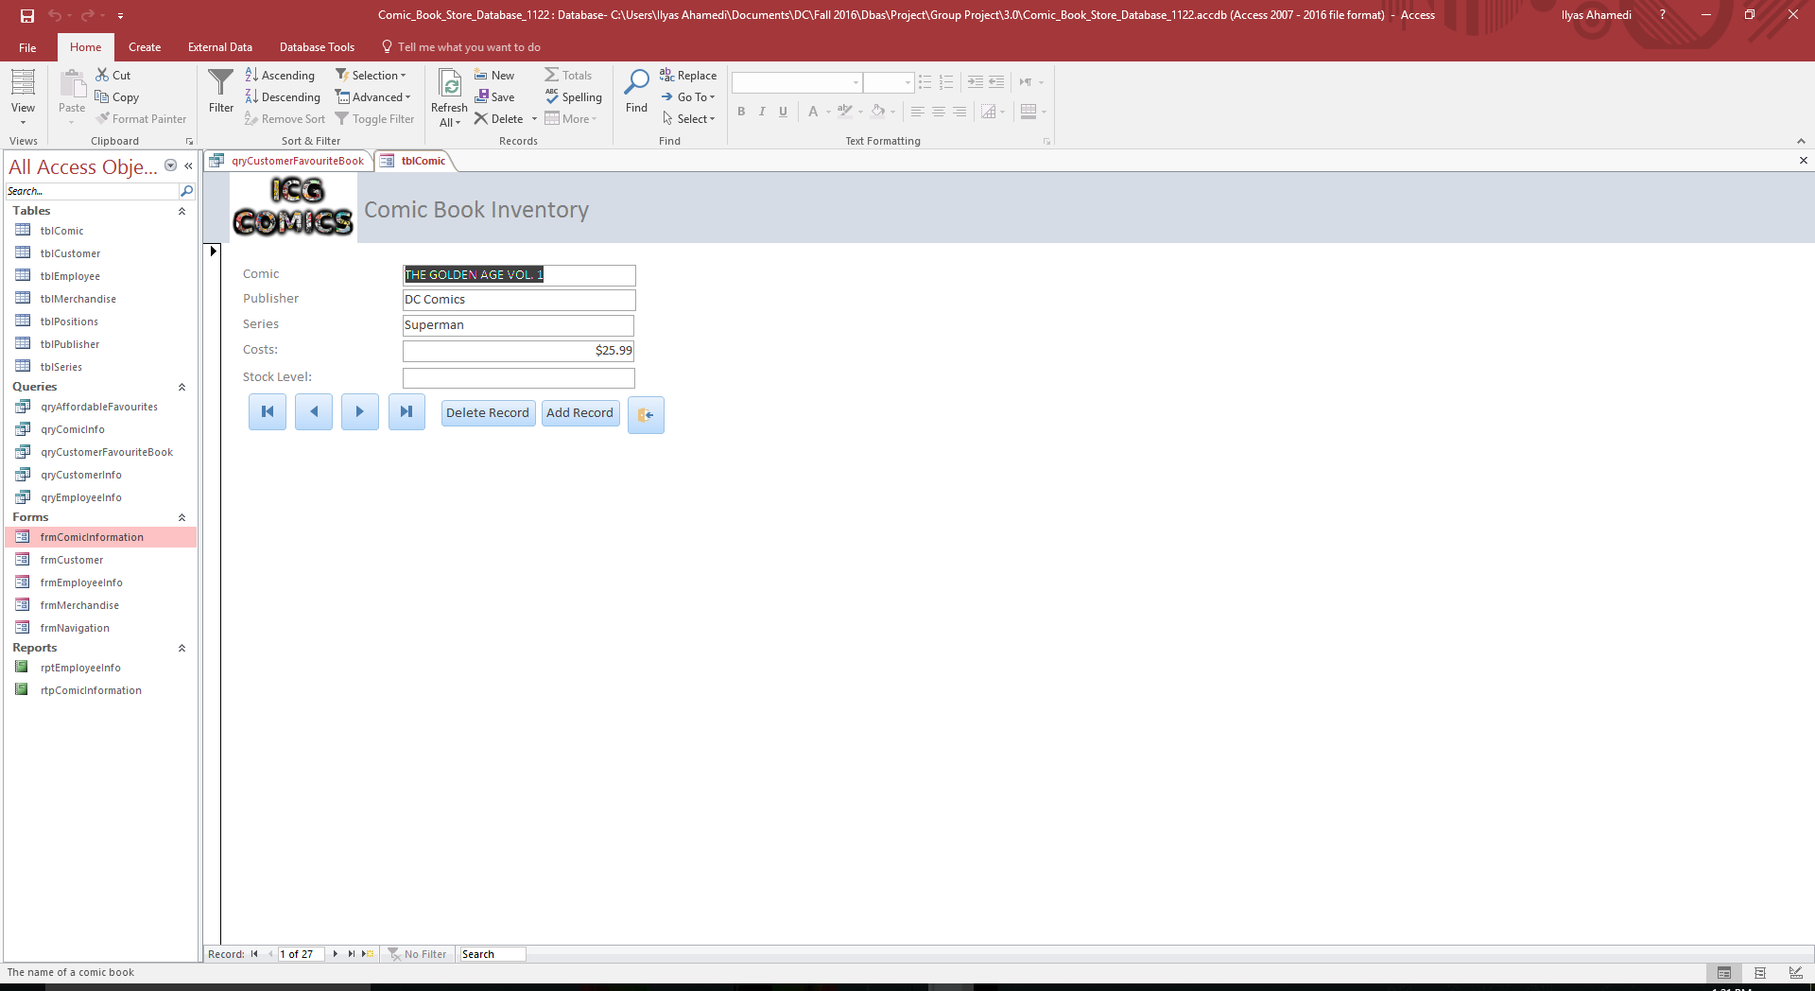

This is the Customer form and it shows the user, information about our customers (Their full name and their email)

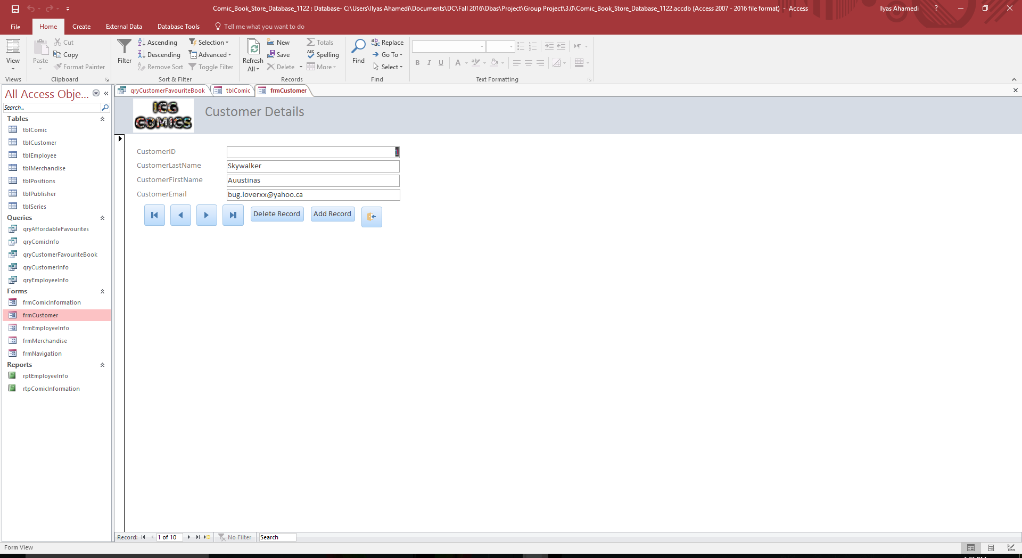

This is the Employee Information form and it show the user, information about our employees working in the comic book store. It tells whoever is viewing the form if the employee is a cashier, a supervisor, or a manager. It also shows the user their pay rate. Finally, it shows their contact information in the form.

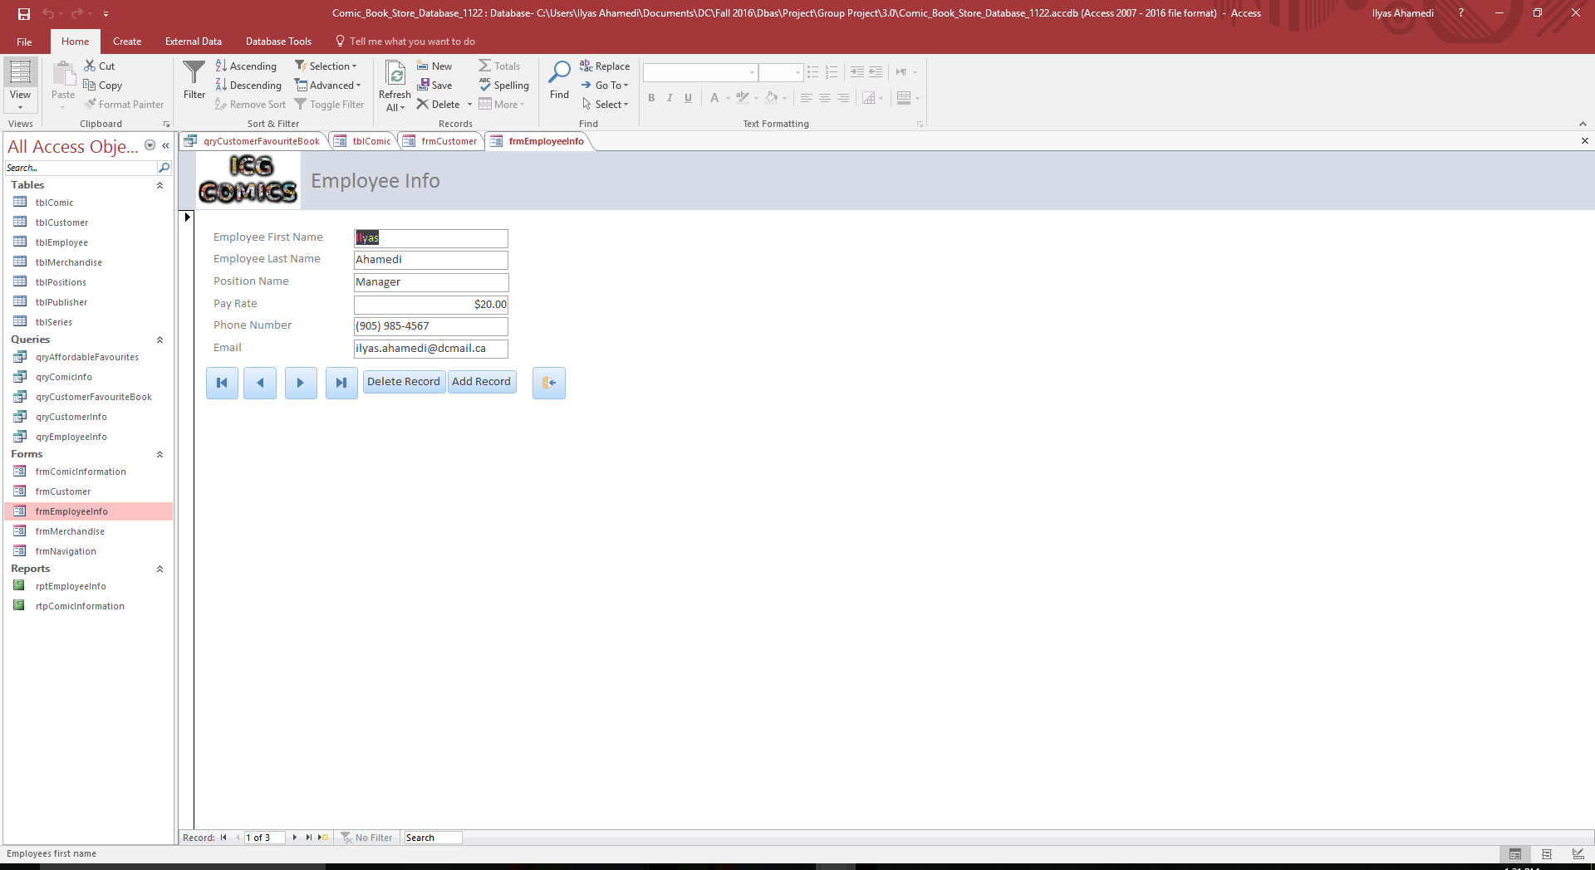

This is the Merchandise form. It is a very simple form that shows the user the product and how much the product costs.

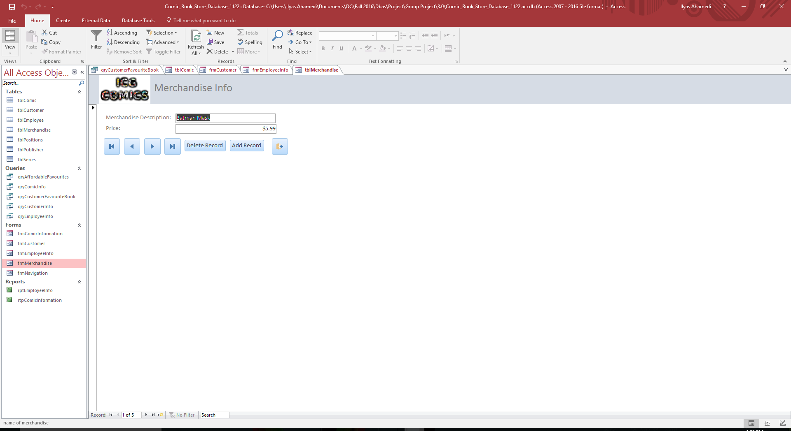

This is the Navigation form and this makes navigating the database easier for an inexperienced user.

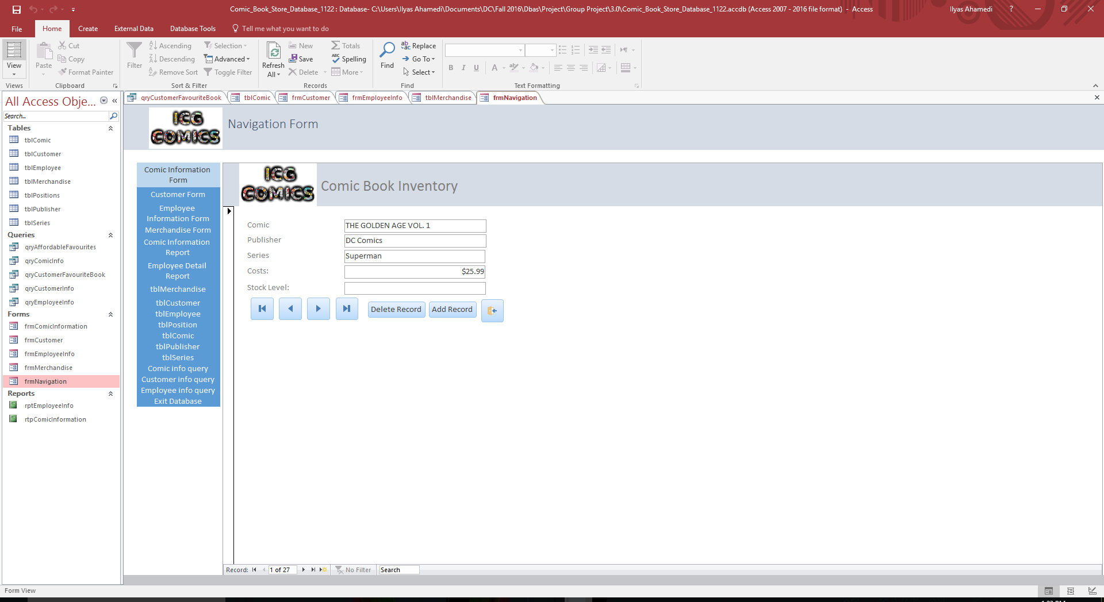

**Report Outputs**

This report shows information on all the comics in the store (Publisher Name, Series Name, and Comic Name)

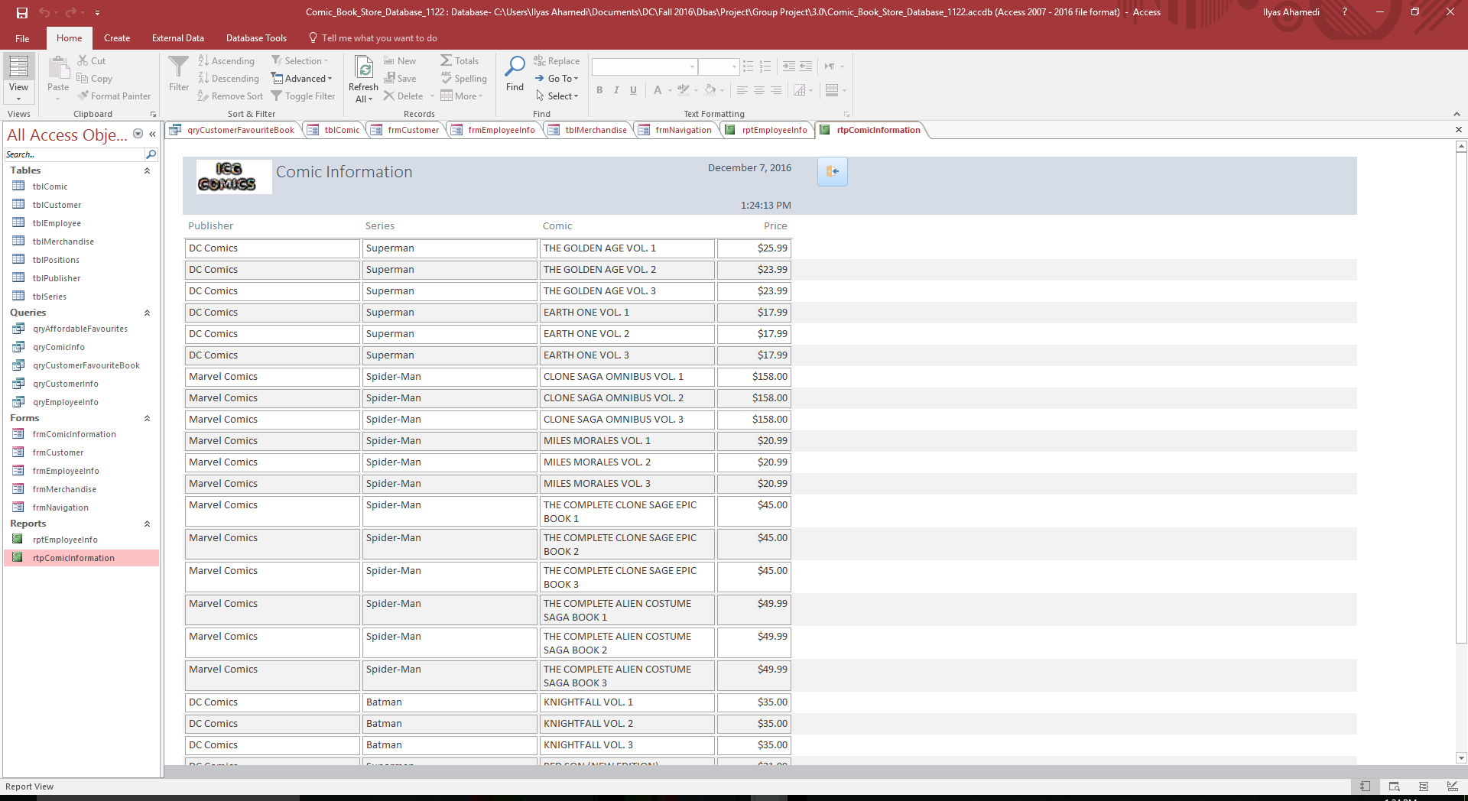

This report shows information on all the employees that work in the store (First Name, Last Name, Position, Pay rate (per hour), Phone number, and email)

